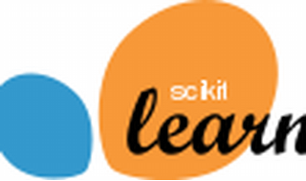

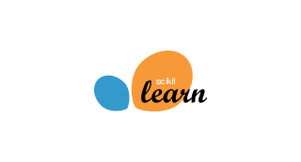

Explore

**Scikit-learn**, also known as **sklearn**, is a **free and open-source machine learning library** for the Python programming language. It provides efficient tools for predictive data analysis, making machine learning accessible to everyone and reusable in various contexts. [Built on **NumPy**, **SciPy**, and **matplotlib**, scikit-learn simplifies the implementation of machine learning algorithms1](https://scikit-learn.org/stable/index.html).

Here are **five free resources** where you can learn more about scikit-learn:

1. [**scikit-learn Tutorials**](https://scikit-learn.org/stable/tutorial/index.html): This official documentation offers tutorials covering topics such as machine learning basics, statistical learning, working with text data, and more[2](https://scikit-learn.org/stable/tutorial/index.html).
2. [**Coursera**](https://www.coursera.org/courses?query=scikit%20learn): Explore multiple scikit-learn courses on Coursera, including topics like linear regression, data science, sentiment analysis, and more[3](https://www.coursera.org/courses?query=scikit%20learn).
3. [**Machine Learning with Scikit-Learn Full Course**](https://www.freecodecamp.org/news/machine-learning-with-scikit-learn-full-course/): A comprehensive YouTube course by freeCodeCamp.org that dives into machine learning using scikit-learn[4](https://www.freecodecamp.org/news/machine-learning-with-scikit-learn-full-course/).
4. [**Introduction to Scikit-learn**](https://inria.github.io/scikit-learn-mooc/): GitHub Pages with introductory materials on Python, NumPy, Pandas, and Matplotlib, essential for scikit-learn learning[5](https://inria.github.io/scikit-learn-mooc/).
5. [**Scikit-learn User Guide**: Explore the official user guide for detailed information on scikit-learn’s functionality and usage](https://scikit-learn.org/stable/index.html)[2](https://scikit-learn.org/stable/tutorial/index.html).

Happy learning! 🚀📚